https://www.jdoodle.com/embed/v0/5RWG
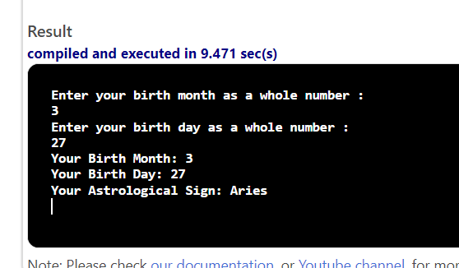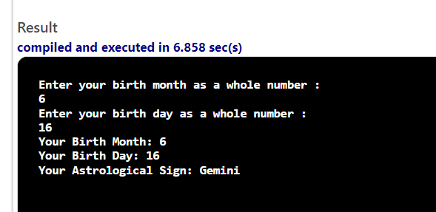

#include <iostream>

using namespace std;

int main()
{
double month,day;
cout<<"Enter your birth month as a whole number <1-12> : "<<endl;
cin>>month;
cout<<"Enter your birth day as a whole number : "<<endl;
cin>>day;

string sign;
if ( ( (month == 3) && ( day>=21 ) ) ||
( ( month == 4 ) && ( day <=19 ) ) )
{
sign="Aries";
}

else if ( ( (month == 4) && ( day> 19 ) ) ||
( ( month == 5 ) && ( day <=20 ) ) )
{
sign="Taurus";
}

else if ( ( (month == 5) && ( day> 21 ) ) ||
( ( month == 6) && ( day <=20 ) ) )
{
sign="Gemini";
}

else if ( ( (month == 6) && ( day> 21 ) ) ||
( ( month == 7) && ( day <=22 ) ) )
{
sign="Cancer";
}

else if ( ( (month == 7) && ( day> 23 ) ) ||
( ( month == 8) && ( day <=22 ) ) )
{
sign="Leo";
}

else if ( ( (month == 8) && ( day> 23 ) ) ||
( ( month == 9) && ( day <=22 ) ) )
{
sign="Virgo";
}

else if ( ( (month == 9) && ( day> 23 ) ) ||
( ( month == 10) && ( day <=22 ) ) )
{
sign="Libra";
}

else if ( ( (month == 10) && ( day> 23 ) ) ||
( ( month == 11) && ( day <=21) ) )
{
sign="Scorpio";
}

else if ( ( (month == 11) && ( day> 22 ) ) ||
( ( month == 12) && ( day <=21 ) ) )
{
sign="Sagittarius";
}

else if ( ( (month == 12) && ( day> 22 ) ) ||
( ( month == 1) && ( day <=19 ) ) )
{
sign="Capricorn";
}

else if ( ( (month == 1) && ( day> 20 ) ) ||
( ( month == 2) && ( day <=18 ) ) )
{
sign="Aquarius";
}

else if ( ( (month == 2) && ( day> 19 ) ) ||
( ( month == 3) && ( day <=20 ) ) )
{
sign="Pisces";
}

cout<<"Your Birth Month: "<<month<<endl;
cout<<"Your Birth Day: "<<day<<endl;
cout<<"Your Astrological Sign: "<<sign<<endl;
return 0;
}

